Amanpreet Kaur Bassi

Web Programming

Professor Plotkin

List of Features in the App

* Heart rate measurement

Screen should be somewhat similar to the image below:

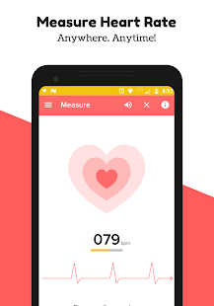

* Map of a circular track that measures how many laps were done while running, at what speed. It would be a simple track screen, which would show how many laps are completed.

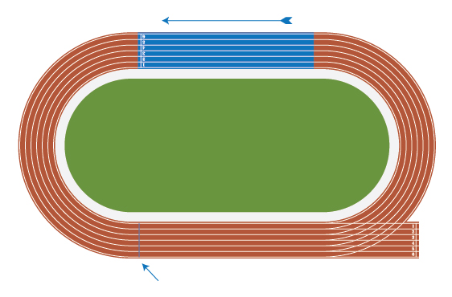

* Nutrition guidance with links to various diet plans in order to gain weight or lose weight, also should give a rough estimate of time and amount of exercise needed to achieve expected results



Screen will display the amount of nutrition needed for weight loss/weight gain or muscle build up.

* Simple timer for weightlifting and other exercises to set a time limit for each exercise

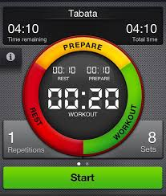

* Links to correct postures for particular exercises

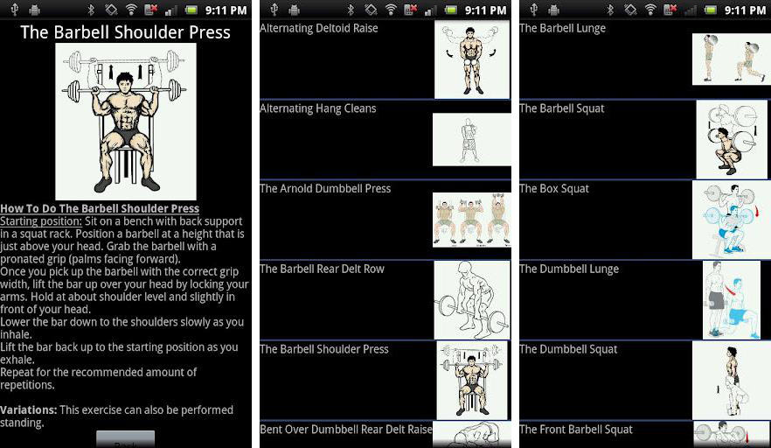

* Try to also add voice input and output as a feature making it user friendly; similar to Alexa, Siri, etc.
* Keeping track of sleeping hours, where a calculator is set up; the bed time is entered by the user before going to sleep as well as wake up time and then results should detect good or bad sleeping conditions.

